Practical 1
Q-1
Step 1 install python and set up vs code

- Open browser.
- Go to official python websites.
- Download Python latest version.
- set up the installation.

Step 2 check python installation

- Open command prompt.
- Write this command: python – version
- See something like; python 3.13.5

Step 3 install python Extension in vs code

- Open Extensions
- Search python
- Install the python extension by Microsoft

Step 4 install juypter Extension

- In Extensions: jupyter
- Install the juypter extension by Microsoft.

Q-2

Step 1:

- Create folder BCA_IDS
- Write a Hello word python code
- Give a filename pro1.py
- Open vs code Terminal
- Run command: python pro1.py

Practical 2
import pandas as pd
data=pd.read_csv("Book1.csv")
print(data.head())
print(data['marks'].max())
print(data['marks'].mean())
print(data['marks'].min())
toper=data.loc[data["marks"].idxmax()]
print(toper['name'],toper['marks'])
print(data.dtypes)
print(data.info())
print(data['marks'].sum())
print(data['marks'].count())
print(data.groupby('subject')['marks'].mean())
print(data.groupby('subject').size())
print(data.sort_values('marks' ,ascending=True))

Output:-
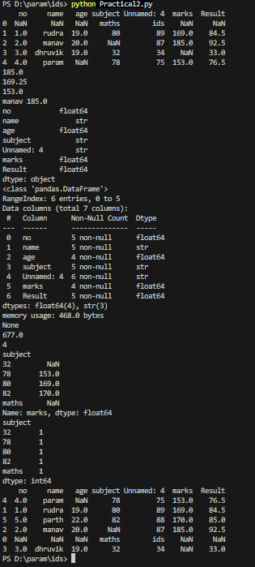

Practical 3
import pandas as pd
data=pd.read_excel("Book.xlsx")
print(data.head(1))
print(data.tail(2))
print(data.shape)
print(data.columns)
print(data.info(1))
Output:-
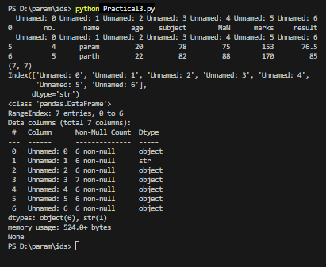

Practical 8
Line chart:
import pandas as pd
import matplotlib.pyplot as plt

df = pd.read_csv('em1.csv')
plt.plot(df['Employee_ID'],df['Salary'])
plt.show()
Output:-
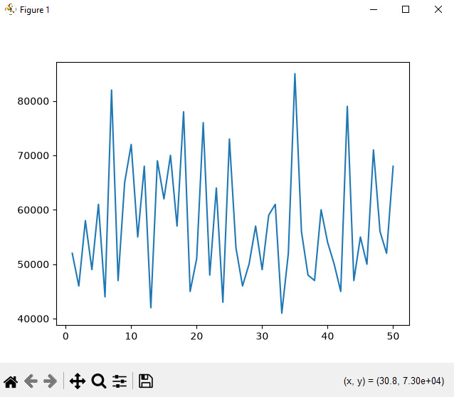
Bar chart:
import pandas as pd
import matplotlib.pyplot as plt

df = pd.read_csv('em1.csv')
plt.bar(df['Employee_ID'],df['Salary'])
plt.show()
Output:-

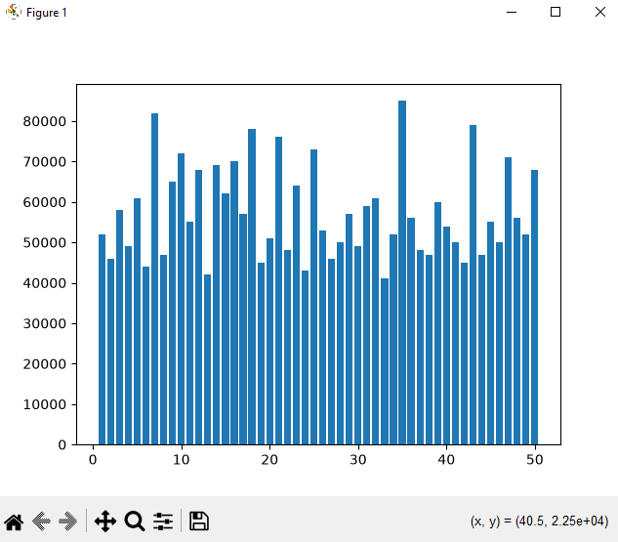

Histogram chart:
import pandas as pd
import matplotlib.pyplot as plt
df = pd.read_csv('em1.csv')
plt.hist(df['Salary'])
plt.show()
Output:-

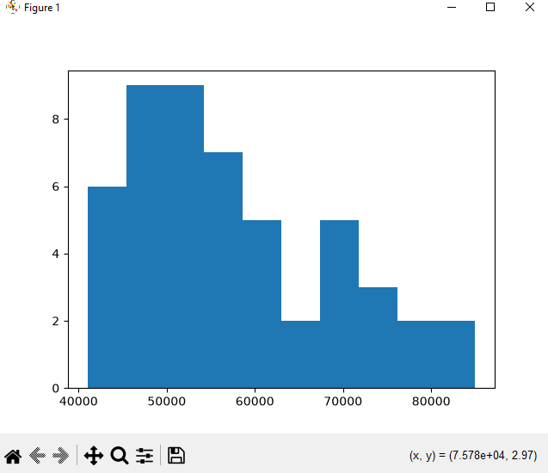

Pie chart:
import pandas as pd
import matplotlib.pyplot as plt

df = pd.read_csv('em1.csv')
plt.pie(df['Salary'], labels=df['Employee_ID'])
plt.show()
Output:-
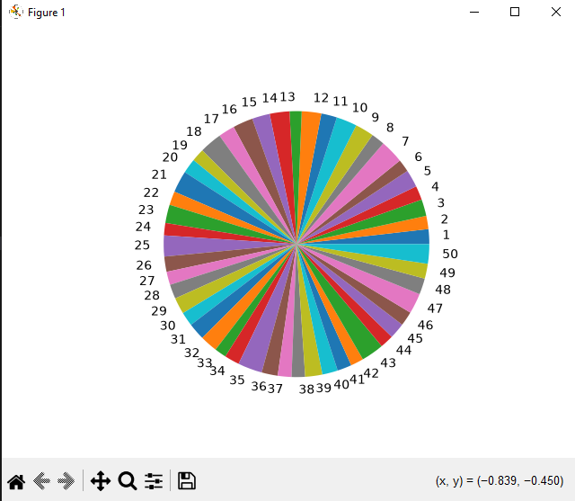

Practical 9
Scatter plot:
import pandas as pd
import matplotlib.pyplot as plt

df = pd.read_csv('em1.csv')
plt.scatter(df['Employee_ID'], df['Salary'])
plt.show()

Output:-

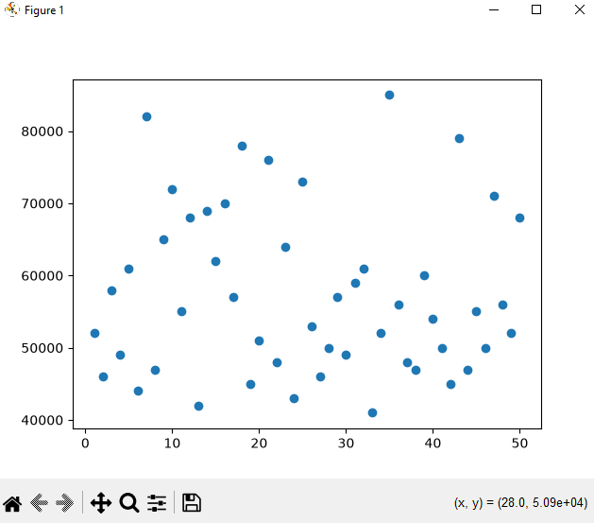

Box plot:
import pandas as pd
import matplotlib.pyplot as plt

df = pd.read_csv('em1.csv')
plt.boxplot(df['Salary'])
plt.show()
Output:-

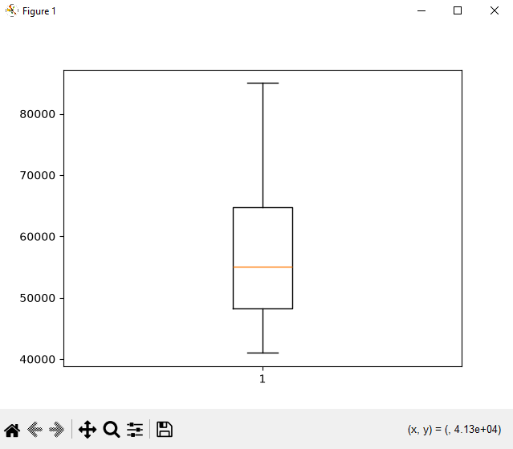
Distribution plot:

